**Lasso Regression**

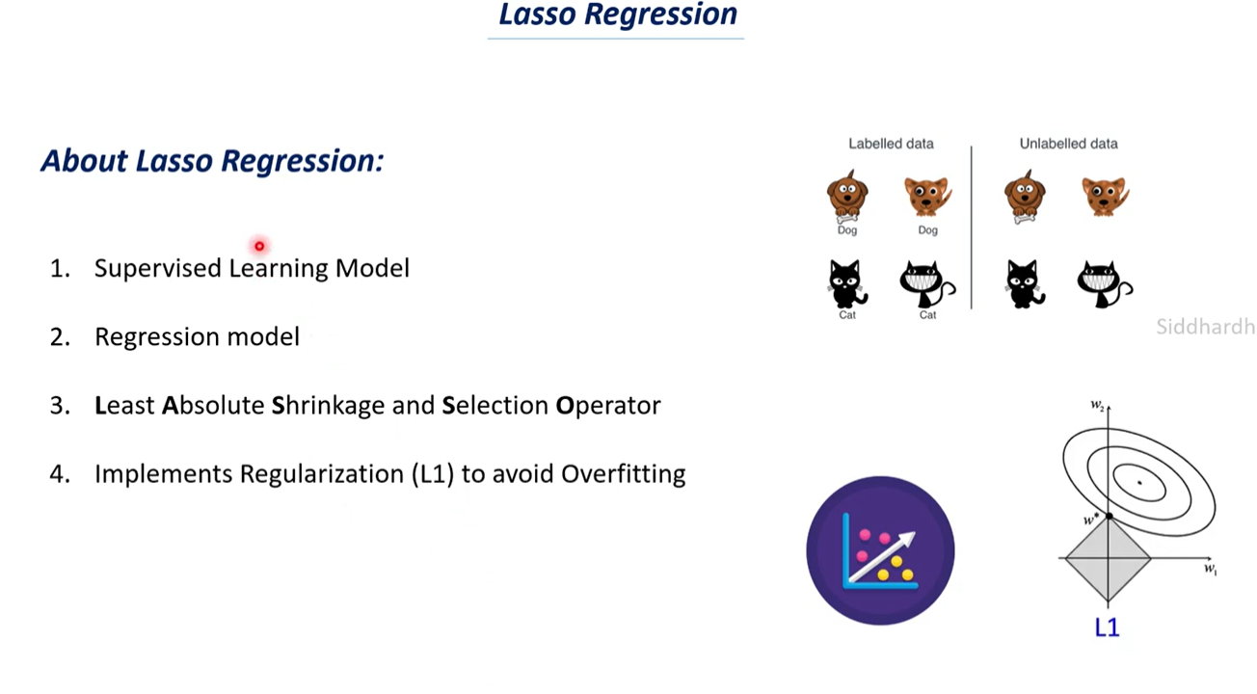

It is build on top of a linear regession model.

As we know linear regression looks like:

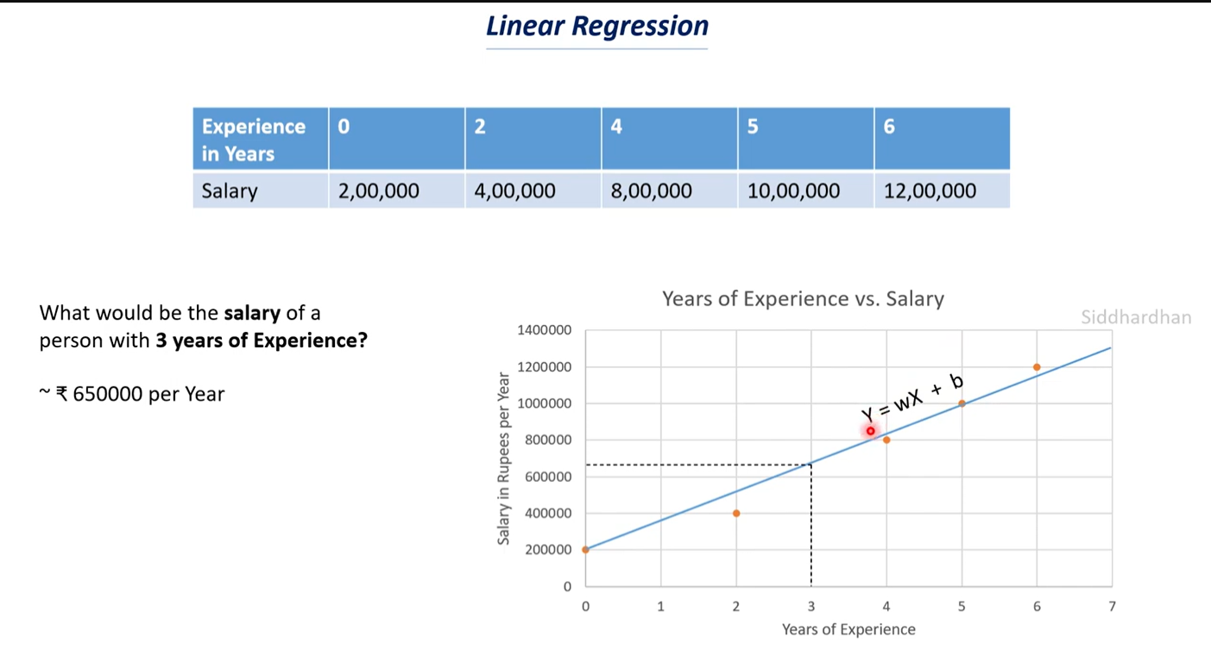

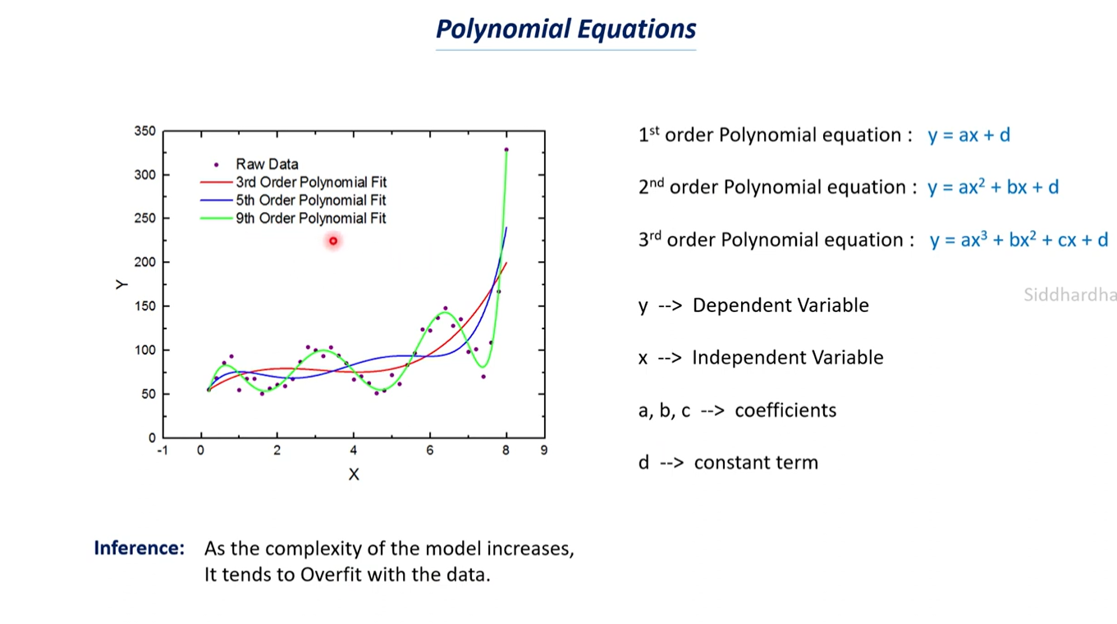

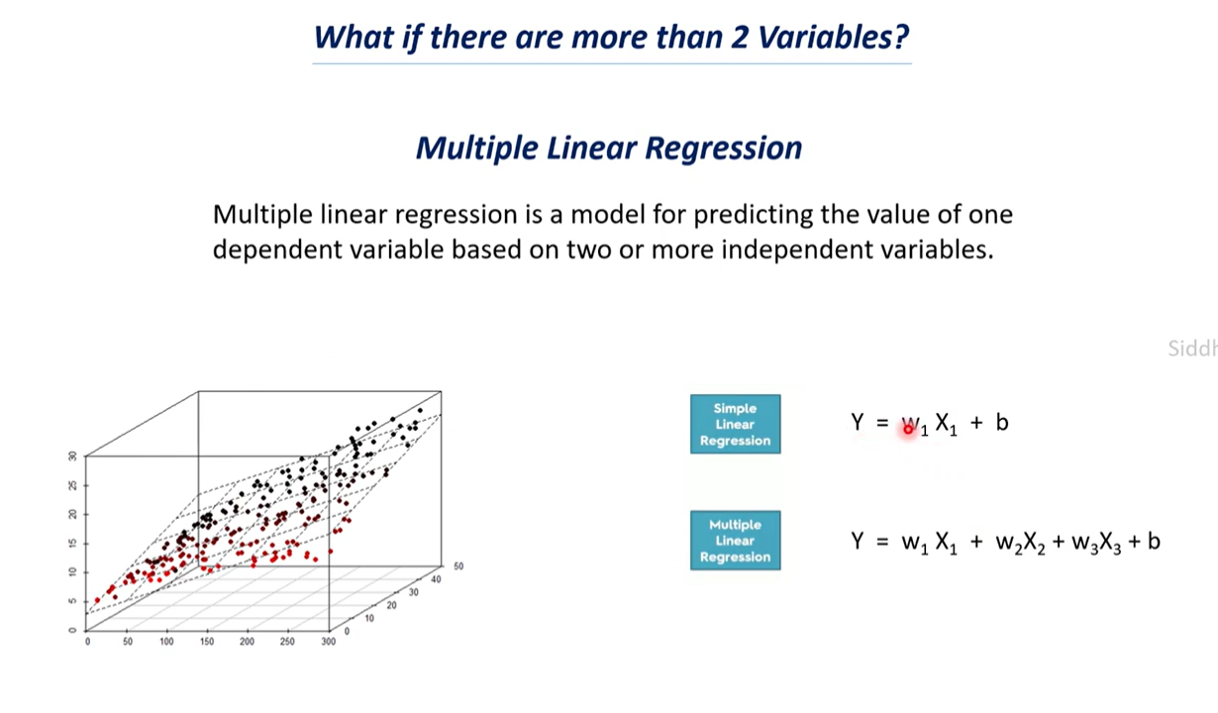

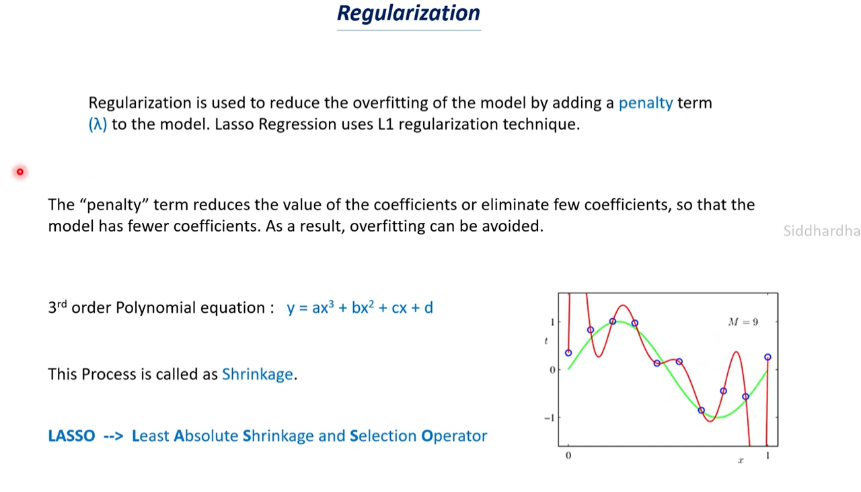

Coefficients= a,b,c,d

Red is the overfitted curve in the diagram, green is the regularized curve.

Suppose we have many features in a dataset, often times all those features won’t be important to us. Eg: out of 20 only 5 features are important, during regularization a lot of coefficients might become 0 and hence we are left with a simple model which has very less chances of overfitting.

**Math Behind Lasso Regression**

Cost function in Linear regression:

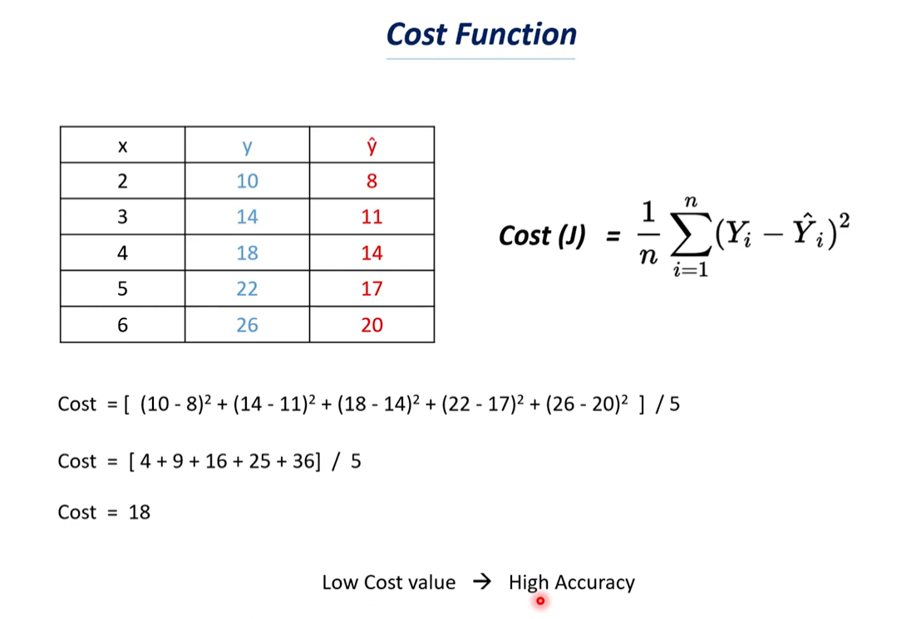

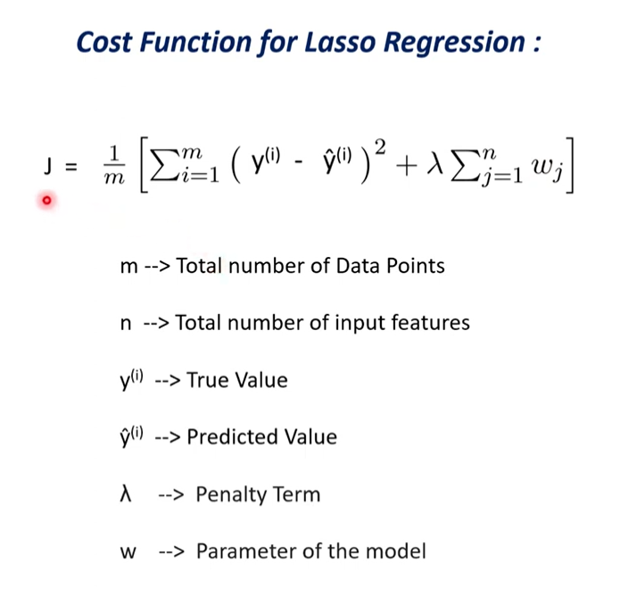

In lasso regression we use a different formula for the cost function.

We add the penalty term to our linear regression cost function.

